Compiler Design Week-2

1.simple calculator program  
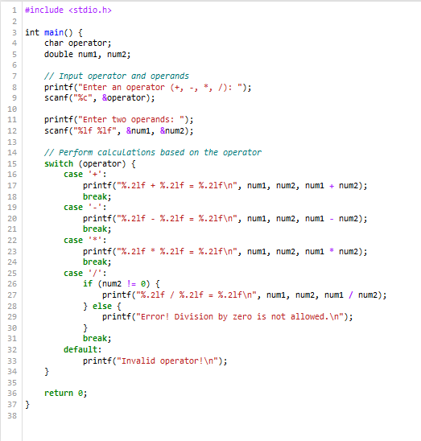

2.To count and print words that have at least two vowels.

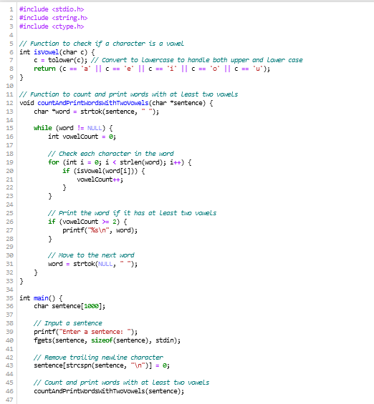

3.Identify the keywords and convert it into Uppercase.

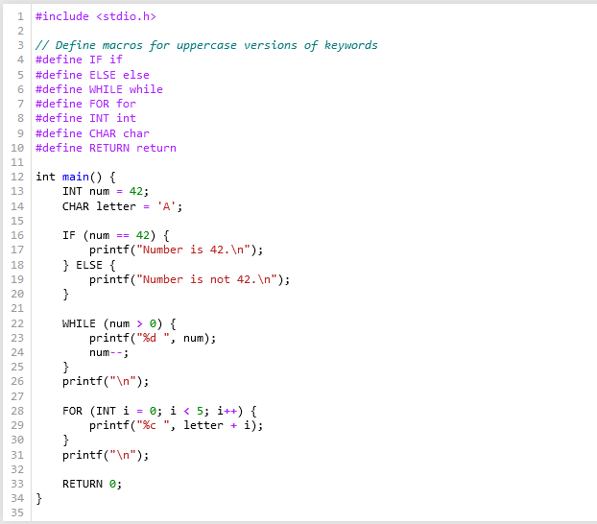

4.To count and print words that are in mixed case

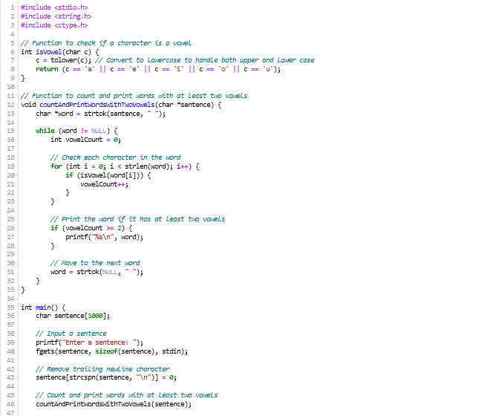

Outputs:  
